**BIT100**

**INTRODUCTION TO PROGRAMMING**

**ASSIGNMENT 2**



**E200312**

**Valentino Yudhistira Jehaut**

Task 1:

Source code from firstassignment_task1.py

# Guess The Number!

# Valentino Yudhistira Jehaut

# E2100312

# Assignment 1

# Task 1

# This code is used to import the function

# "randint" from the "random library"

from random import randint

# This code is used as the main function of the game

def main():

totalGuesses = 1

low_value,max_value = 0,100

# This code is used to get a random number, which

# the number will be used as the answer for the game

randNum = randint(low_value, max_value)

# This code is used to insert the player's

# guess number for the first time

playerGuessNumber = int(input("Range "+str(low_value)+" --> "+str(max_value)+". Your guess? "))

# This code validates the player's answer and

# compares it with the answer of the game

while playerGuessNumber != randNum:

# This code is used to reject player's guess if

# the player's guess is above/below the current

# min & max value

if playerGuessNumber < low_value or playerGuessNumber > max_value:

print('Incorrect!\n')

# This code is used to increase/decrease the range

# each time the player enters their guessed number

elif playerGuessNumber < randNum:

low_value = playerGuessNumber + 1

print('Incorrect!\n')

else:

max_value = playerGuessNumber - 1

print('Incorrect!\n')

# This code is used to insert the player's

# guess number everytime the player's turn

playerGuessNumber = int(input("Range "+str(low_value)+" --> "+str(max_value)+". Your guess? "))

# This code is used to repeat the player's turn each

# time the player tries to input the guessed number

totalGuesses+=1

# This code checks the player's total guess and displays how many tries

# did the user try to get the answer. And, if the player's tries

# less than 5 tries, it will display that the player is lucky today.

if totalGuesses < 5:

print('\nCongratulation! You have done it in ' + str(totalGuesses) + ' tries!')

print('You are lucky today!')

else:

print('\nCongratulation! You have done it in ' + str(totalGuesses) + ' tries!')

main()

Output:

If the player guesses less than 5 times:

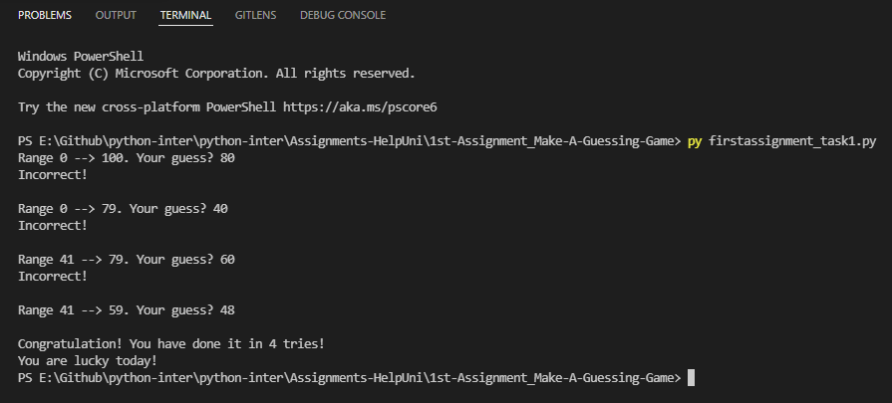

If the player guesses more than 5 times:

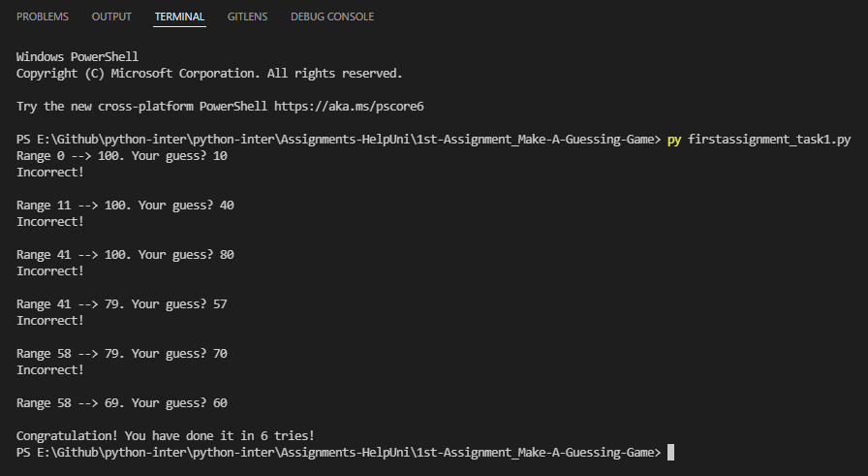

Task 2: Player vs Player

Source code from firstassignment_task2.py

# Guess The Number!

# Valentino Yudhistira Jehaut

# E2100312

# Assignment 1

# Task 2 (Player vs Player)

# This code is used to import the function

# "randint" from the "random library" from random import randint

#This code is used as the main function to run the game

def main():

player1,player2 = "Player 1","Player 2"

low_value,max_value = 0,100

currentPlayer = player1

# This code is used to get a random number, which

# number will be used as the answer for the game

randNum = randint(low_value, max_value)

# This code is used to insert the player's

# guess number for the first time

print(currentPlayer)

playerGuessNumber = int(input("Number ranges from "+str(low_value)+" to "+str(max_value)+".\nWhat is your guess? "))

#This code is used to run the game on loop sequence

while True:

# This code runs when the result from one of the

# players matches with the final answer from the game

if playerGuessNumber == randNum:

print("\nCongratulations! ",currentPlayer, "wins")

# This code is used to end the game

exit()

# This code is used to select when it's the first player's turn

elif currentPlayer == player1:

# This code is used to switch turns from player1

# to player2 after the game displays the result

currentPlayer = player2

# This code validates the player's answer and

# compares it with the answer of the game

if playerGuessNumber < low_value or playerGuessNumber > max_value:

print('Incorrect!\n')

# This code is used to increase/decrease the range

# each time player1 enters their guessed number

elif playerGuessNumber < randNum:

low_value = playerGuessNumber + 1

print('Incorrect!\n')

else:

max_value = playerGuessNumber - 1

print('Incorrect!\n')

# This code is used to select when it's the second player's turn

elif currentPlayer == player2:

# This code is used to switch turns from player2

# to player1 after the game displays the result

currentPlayer = player1

# This code validates the player's answer and

# compares it with the answer of the game

if playerGuessNumber < low_value or playerGuessNumber > max_value:

# This code will display "Incorrect" if the

# player's guess isn't the same as the answer

print('Incorrect!\n')

# This code is used to increase/decrease the

# range each time player2 enters their guessed number

elif playerGuessNumber < randNum:

low_value = playerGuessNumber + 1

print('Incorrect!\n')

else:

max_value = playerGuessNumber - 1

print('Incorrect!\n')

#This code displays the current player

print(currentPlayer)

# This code is used to insert the player's

# guess number everytime the player's turn

playerGuessNumber = int(input("Number ranges from "+str(low_value)+" to "+str(max_value)+".\nWhat is your guess? "))

main()

Output :

If Player1 Wins:

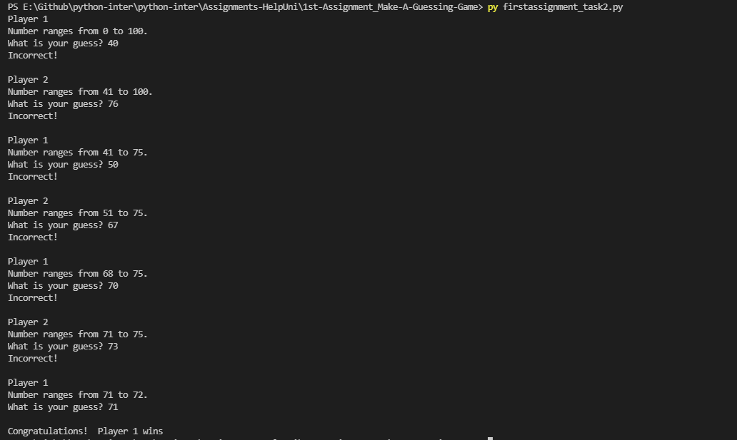

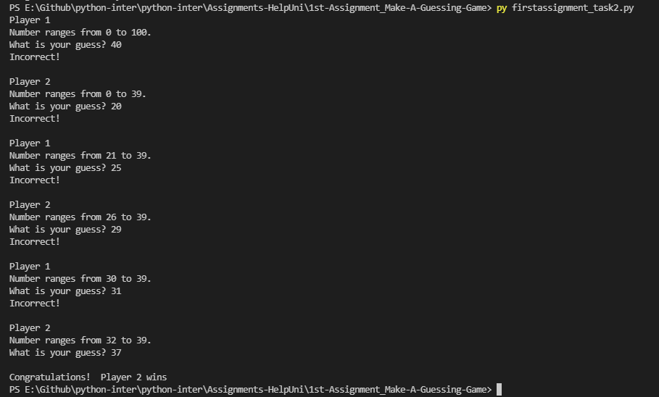If Player2 Wins:

Task 3 = Player vs Computer

Source code from firstassignment_task3.py

# Guess The Number!

# Valentino Yudhistira Jehaut

# E2100312

# Assignment 1

# Task 3 (Player vs Computer)

# This code is used to import the function

# "randint" from the "random library"

from random import randint

# This code is used as the main function to run the game

def main():

player,comp = "Player","Computer"

low_value,max_value = 0,100

currentUser = player

keep_playing = "True"

# This code is used to get a random number, which number

# will be used as the answer for the game

randNum = randint(low_value, max_value)

# This code is used to show the prompt in which the player's

# is need to insert the guess number for the first time

print("Player: "+currentUser)

playerGuessNumber = int(input("Number ranges from "+str(low_value)+" to "+str(max_value)+".\nWhat is your guess? "))

# This code is used to run the game on loop sequence

while keep_playing == "True":

# This code is used to select when it's the player's turn

if currentUser == player:

# This code is used to switch turns from player

# to computer after the game shows the results

currentUser = comp

# This code validates the player's answer and

# compares it with the answer of the game

if playerGuessNumber == randNum:

# This code is used change turns from player to

# computer after the game shows the results

currentUser = player

# This code used to show if the player wins

# the current game session

print("\n"+currentUser+" wins")

#This code is used to end the game

exit()

# This code is used to reject player's guess if the player's

# guess is above/below the current min & max value

elif playerGuessNumber < low_value or playerGuessNumber > max_value:

print('Incorrect!\n')

#This code is used to show the next user's turn

print('Player:',currentUser)

# This code is used to increase/decrease the range

# each time the player enters their guessed number

elif playerGuessNumber < randNum:

low_value = playerGuessNumber + 1

print('Incorrect!\n')

print('Player:',currentUser)

else:

max_value = playerGuessNumber - 1

print('Incorrect!\n')

print('Player:',currentUser)

# This code runs when it's the computer's turn

if currentUser == comp:

# This code is used change turns from player to computer

# after the game shows the results

currentUser = player

# This code is used for the computer to guess the

# answer from this game session

computerResult = randint(low_value,max_value)

# This code is used as a function for the computer to

# guess the answer from this game session

def compShow(low_value,max_value,computerResult):

print("Number ranges from "+str(low_value)+" to "+str(max_value)+".")

print('Computer guess',computerResult)

# This code validates the computer's answer

# and compares it with the answer of the game

if computerResult == randNum:

# This code is used change turns from computer

# to player after the game shows the results

currentUser = comp

# This code function is used for the computer

# to guess the answer from this game session

compShow(low_value,max_value,computerResult)

#This code used to show if the computer wins the game

print("\n"+currentUser+" wins")

#This code is used to end the game

exit()

# This code is used to reject computer's guess if the

# min & max value is above the current min & max value

elif computerResult < low_value or computerResult > max_value:

compShow(low_value,max_value,computerResult)

# This code will display "Incorrect" if the

# computer's guess isn't the same as the answer

print('Incorrect!\n')

#This code is used to show the next user's turn

print('Player:',currentUser)

# This code is used to increase/decrease the range

# each time the computer enters their guessed number

elif computerResult < randNum:

low_value = computerResult + 1

compShow(low_value,max_value,computerResult)

print('Incorrect!\n')

print('Player:',currentUser)

else:

max_value = computerResult - 1

compShow(low_value,max_value,computerResult)

print('Incorrect!\n')

print('Player:',currentUser)

# This code is used to insert the player's

# guess number every time it’s the player's turn

playerGuessNumber = int(input("Number ranges from "+str(low_value)+" to "+str(max_value)+".\nWhat is your guess? "))

main()

Output:

If Player Wins:

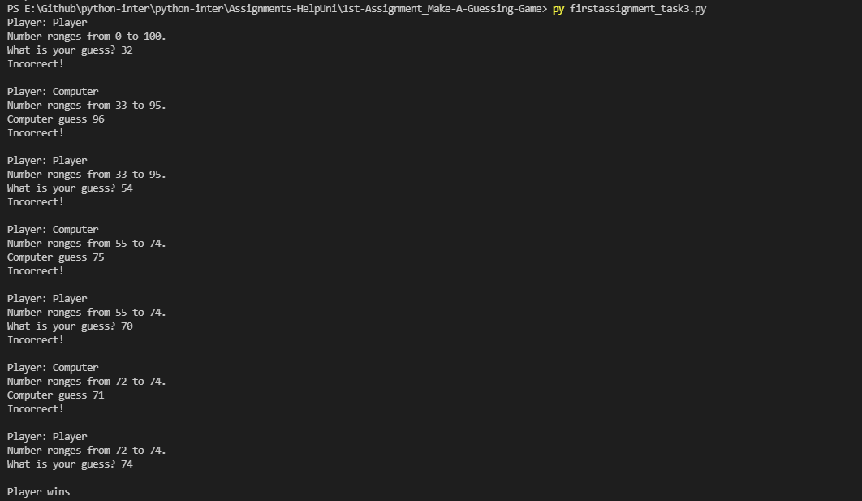

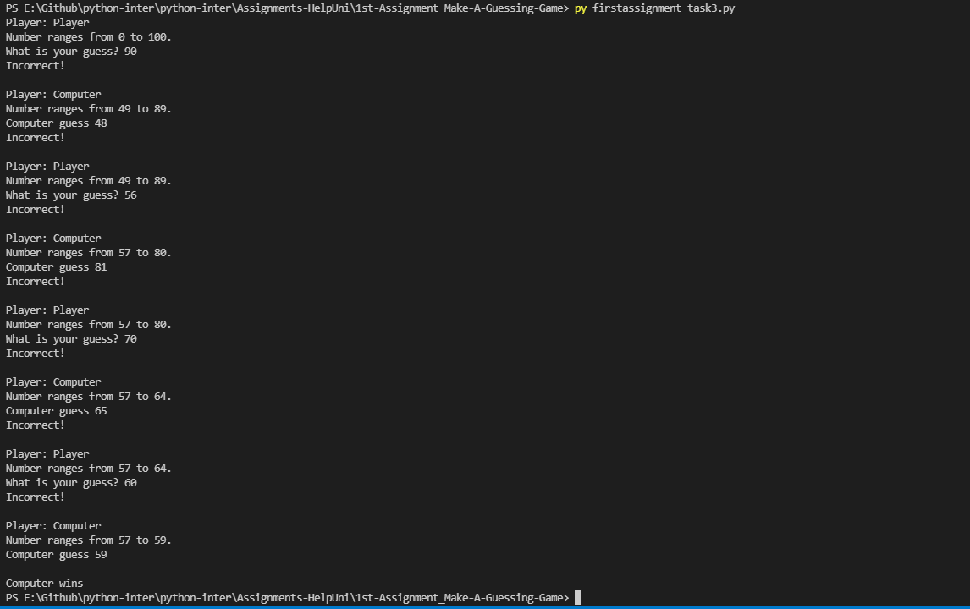If Computer Wins:

Task 4 = Player vs Computer with Game Sessions

Source code from firstassignment_task4.py

# Guess The Number!

# Valentino Yudhistira Jehaut

# E2100312

# Assignment 1

# Task 4 (Player vs Computer with Game Sessions)

# This code is used to import the function "randint"

# from the "random library"

from random import randint

# This code is used as the

# main function to run the game

def main():

var_game = 1

player,comp = "Player","Computer"

currentPlayerScore = 0

currentCompScore = 0

theWinner = player

keep_playing = "True"

# This code is used to run the game on loop sequence

while keep_playing == "True":

currentGuess = -1

totalCounts = 0

low_value,max_value = 0,100

# This code is used to get a random number, which number will

# be used as the answer for the current game session

randomNumber = randint(low_value, max_value)

# This code displays the current game session

print("Game:",str(var_game))

# This code is used to run the game if the player/computer

# guessed number isn't the same as the answer

while currentGuess != randomNumber:

# This code is used to switch positions if the player wins

if theWinner == player:

# This code is used to detect if the

# current turn is player or computer

if totalCounts%2 == 0:

currentUser = player

else:

currentUser = comp

# This code is used to switch positions if the player wins

else:

# This code is used to detect if the

# current turn is player or computer

if totalCounts%2 == 0:

currentUser = comp

else:

currentUser = player

# This code displays the current user and the range of the answer

print("Player:",currentUser)

print("Range "+str(low_value)+" --> "+str(max_value)+".",end = ' ')

# This code is used to ask the player/computer for input which

# will be used to guess the answer from this game session

if currentUser == player:

# This code is used for the player to guess the answer

# from this game session

currentGuess = eval(input("Your guess? "))

elif currentUser == comp:

# This code is used for the computer to guess the answer

# from this game session

currentGuess = randint(low_value,max_value)

print("Computer guess "+str(currentGuess))

# This code is used to increase/decrease the range each

# time the player/computer enters their guessed number

if currentGuess < randomNumber:

low_value = currentGuess + 1

if currentGuess > randomNumber:

max_value = currentGuess - 1

# This code is used to display "Incorrect" if the player/computer

# guessed number isn't the same as the answer

if currentGuess != randomNumber:

print("Incorrect!\n")

# This code is used to repeat the turn if the player/computer

# has entered their answer

totalCounts = totalCounts + 1

# This code used to show if the player/computer wins the

# current game session

print(currentUser,"wins\n")

# This code is used to get the Winner of the current game session

# and the winner of the current game session will be the first to

# start at the next game session

theWinner = currentUser

# This code is used to add a score whenever

# the player/computer wins on each turn

if currentUser == player:

currentPlayerScore = currentPlayerScore + 1

elif currentUser == comp:

currentCompScore = currentCompScore + 1

# This code is used if the player/computer score is already 3 turns

if currentPlayerScore == 3 or currentCompScore == 3:

# This code displays the total score of both

# the player and the computer

print("Score: 'Human': "+str(currentPlayerScore)+" 'Computer': "+str(currentCompScore)+".",end = ' ')

# This code is used to decide the Winner and displays the

# final decision if one of them is the Winner

if currentPlayerScore > currentCompScore:

print("Winner is Player")

else:

print("Winner is Computer")

#This code is used to end the game

keep_playing = "False"

# This code is used to repeat the game session if the

# player/computer turn is already done

var_game+=1

main()

Output:

If Player Wins:

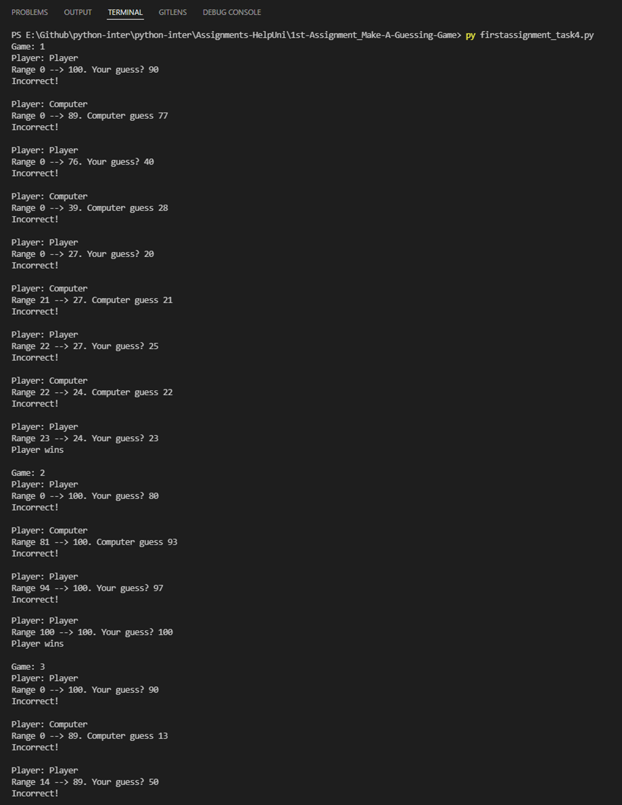

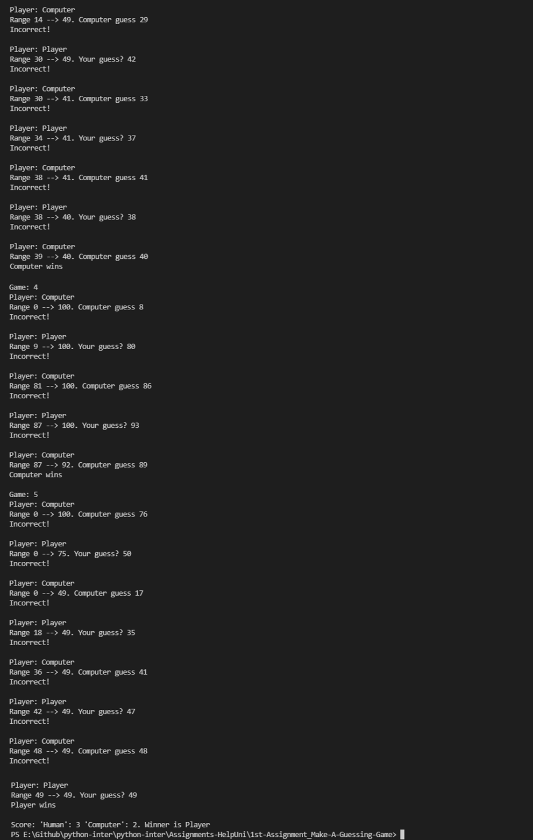

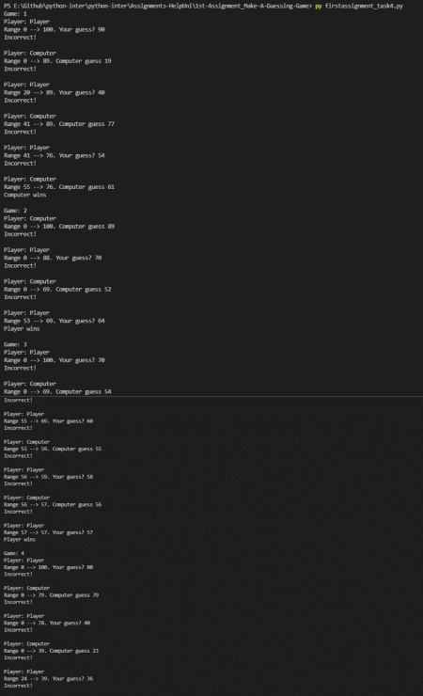If Computer Wins:

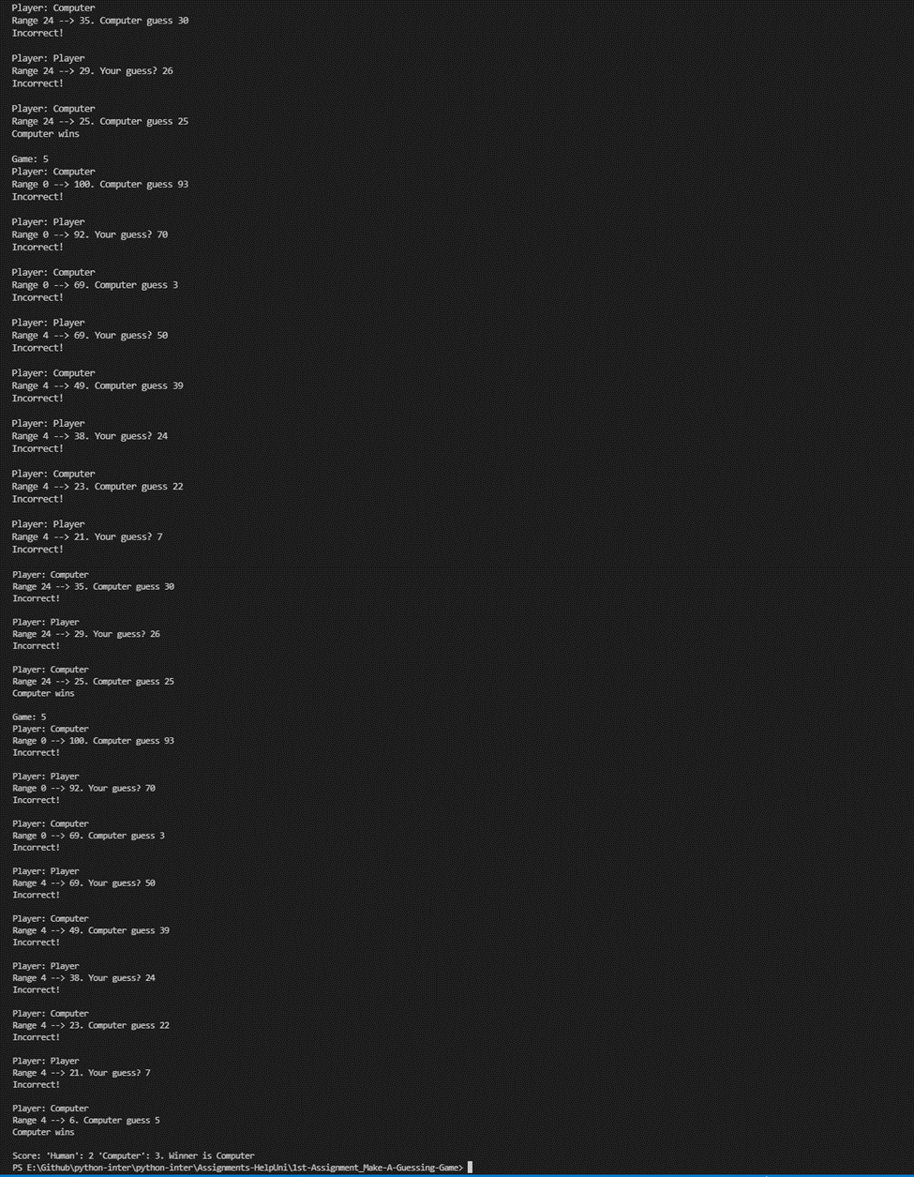

Task 5 = Player vs Computer with Game Sessions and using custom functions

Source code from firstassignment_task5.py

# Guess The Number!

# Valentino Yudhistira Jehaut

# E2100312

# Assignment 1

# Task 5 (Player vs Computer with Game

# Sessions and using custom functions)

# This code is used to import the function "randint"

# from the "random library"

from random import randint

# This code is used as a function to display input for

# players or display input from the computer based on

# the current turn

def dealWithATurn(currentPlayer,start,end):

# This code displays the current user

# and the range of the answer

print("Player:",currentPlayer)

print("Range "+str(start)+" --> "+str(end)+".",end = ' ')

# This code is used to ask the player/computer for input which

# will be used to guess the answer from this game session

if currentPlayer == "Player":

currentGuess = eval(input("Your guess? "))

elif currentPlayer == "Computer":

# This code is used for the computer to guess

# the answer from this game session

currentGuess = randint(start,end)

print("Computer guess "+str(currentGuess))

# This code is used to get the current guess of

# player/computer and returns the guess to the main function

return currentGuess

# This code is used as a function to display the total score of

# player/computer from all the game sessions and displays the

# result if one of them is the winner in this game.

def displayFinalResult(currentPlayerScore,currentCompScore):

#This code displays the total score of

# both the player and the computer

print("Score: 'Human': "+str(currentPlayerScore)+" 'Computer': "+str(currentCompScore)+".",end = ' ')

# This code is used to decide the winner and

# displays the final decision if one of them

# is the winner

if currentPlayerScore > currentCompScore:

print("Winner is Player")

else:

print("Winner is Computer")

# This code is used as the

# main function to run the game

def main():

var_game = 1

currentPlayerScore = 0

currentCompScore = 0

player = "Player"

comp = "Computer"

keep_playing = "True"

theWinner = player

# This code is used to run the game on loop sequence

while keep_playing == "True":

currentGuess = -1

totalCounts = 0

start,end = 0,100

# This code is used to get a random number, which number will

# be used as the answer for the current game session

randomNumber = randint(start, end)

# This code displays the current game session

print("Game:",str(var_game))

# This code is used to run the game if the player/computer

# guessed number isn't the same as the answer

while currentGuess != randomNumber:

# This code is used to switch positions if the player wins

if theWinner == player:

# This code is used to detect if the

# current turn is player or computer

if totalCounts%2 == 0:

currentPlayer = player

else:

currentPlayer = comp

# This code is used to switch positions if the computer wins

else:

# This code is used to detect if the

# current turn is player or compute

if totalCounts%2 == 0:

currentPlayer = comp

else:

currentPlayer = player

# This code function is used to display the last score

# of the player/computer and display the result

# if one of them is the winner in this game.

currentGuess = dealWithATurn(currentPlayer,start,end)

# This code is used to increase/decrease the range each

# time the player/computer enters their guessed number

if currentGuess < randomNumber:

start = currentGuess + 1

if currentGuess > randomNumber:

end = currentGuess - 1

# This code is used to display "Incorrect" if the player/computer

# guessed number isn't the same as the answer

if currentGuess != randomNumber:

print("Incorrect!\n")

# This code is used to repeat the turn if the player/computer

# has entered their answer

totalCounts = totalCounts + 1

# This code used to show if the player/computer wins the

# current game session

print(currentPlayer,"wins\n")

# This code is used to get the Winner of the current game session

# and the winner of the current game session will be the first

# to start at the next game session

theWinner = currentPlayer

# This code is used to add a score whenever

# the player/computer wins on each turn

if currentPlayer == player:

currentPlayerScore = currentPlayerScore + 1

elif currentPlayer == comp:

currentCompScore = currentCompScore + 1

#This code is used if the player/computer score is already 3 turns

if currentPlayerScore == 3 or currentCompScore == 3:

# This code function is used to display the total score of

# player/computer from all the game sessions and displays

# the result if one of them is the winner in this game.

displayFinalResult(currentPlayerScore,currentCompScore)

#This code is used to end the game

keep_playing = "False"

# This code is used to repeat the game session if the

# player/computer turn is already done

var_game+=1

main()

Output:

If Player Wins :

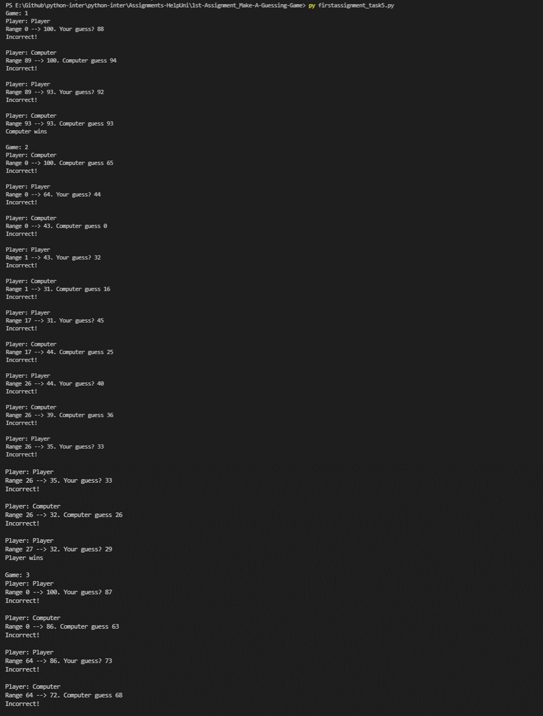

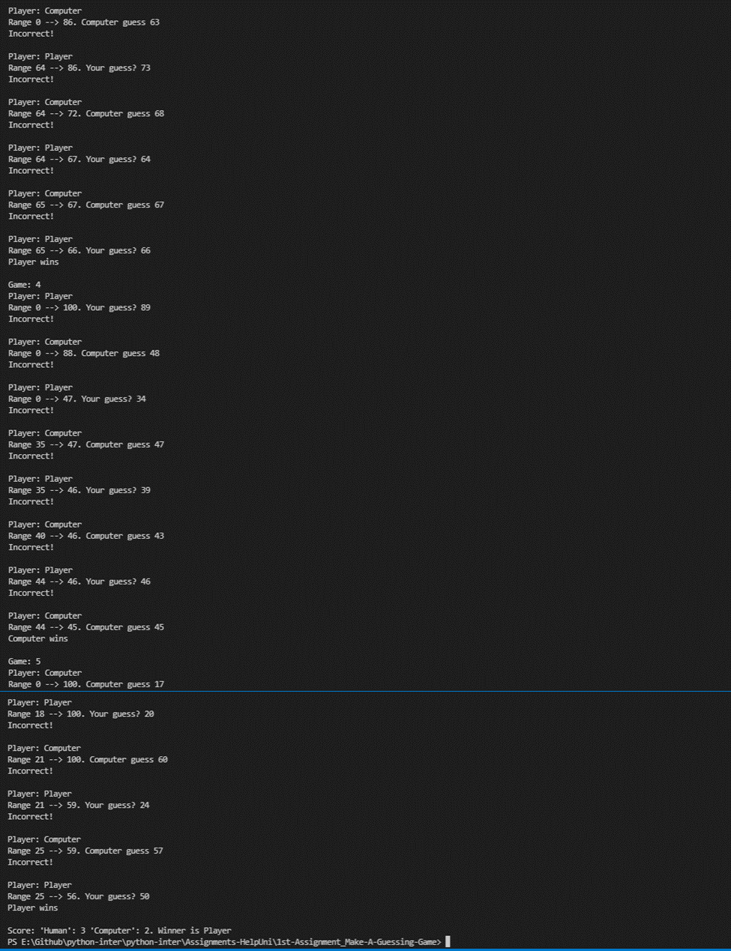

If Computer Wins :

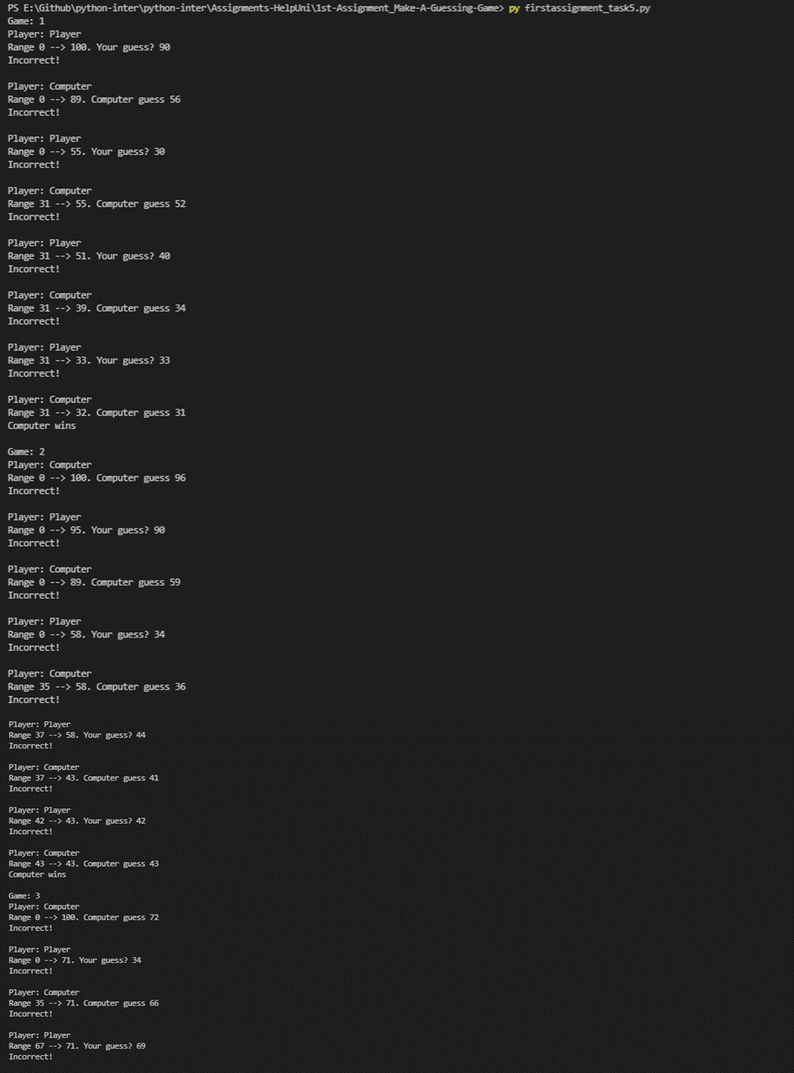



Question 2 (Based on task 2) :

Analysis :

The user wants to play a guessing game with another player. The players will take turns to guess the right number from 1 to 100. And the winner of the game will be congratulated by the game.

Requirement Specification:

Design:

Prompts the user for input (User’s guessed number)

Process it to

Testing:

Operation & Maintenance: